14.45: Let the width be w and the depth at the bottom of the gate be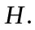 The force on a strip of vertical thickness 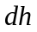at a depth is then 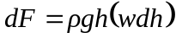 and the torque about the hinge is 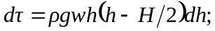 integrating from 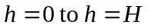 gives 